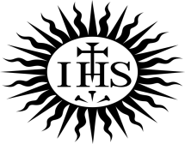
CORPUS CHRISTI PARISH BOSCOMBE : OUTREACH 5thApril 2020

Calling all our Parishioners 3.

Dear Friends, We have lived through another extraordinary week, bringing with it dramatic changes to everyday life. It is such a strange time that we are experiencing with pandemic fears and lockdowns, etc., but most especially it is strange to not have you praying with us in church. I imagine this is as distressing for you as it is for us. As you know, we are trying to develop ways to stay connected with you all. We are all in this together as a Parish. So let’s keep praying in communion and solidarity with one another and stay in touch. Stay well.

PLEASE PRAY FOR THE SICK IN THE PARISH: Sally Lees, Frank Brooks, Carmel Rippington, Michael Crich, Joyce Smith and Angela Hagley.
RIP ANNIVERSARIES THIS WEEK: Clare Grant Hanlon and Stella Hoare.

It was so moving, on Friday, to watch Pope Francis walk alone across an empty St Peter’s Square in the pouring rain, to bless the City and the World. It reminded me of St Ignatius of Loyola’s prayer:
“O Jesus, when all is darkness and we feel our weakness, give us the sense if your presence, your love and your strength. Help us to have perfect trust in your protecting love and strengthening power, so that nothing may frighten or worry us, for living close to you, we shall see your hand, your purpose, your will through all things. Amen”.

On Sunday April 5th we begin Holy Week, the most important week in the church’s year and in our own lives.

AN INVITATION

THE HONOUR OF YOUR PRESENCE IS REQUESTED FOR THE COMMEMORATION OF THE PASSION, DEATH AND RESURRECTIION OF OUR LORD JESUS CHRIST

All the ceremonies of Holy Week will be LIVE STREAMED so we can join in prayerfully from home.

FOR LIVE MASS AND CEREMONIES from St. John’s Cathedral, Portsmouth https://www.portsmouthcatholiccathedral.org.uk/live-mass.php

Or browse online. There are many local churches now offering live streaming.
The SISTERS are also offering special times of live streamed prayer to help us live HOLY WEEK differently this year : https://www.youtube.com/channel/UCXSht03CJERYpTF7NSHcwKw
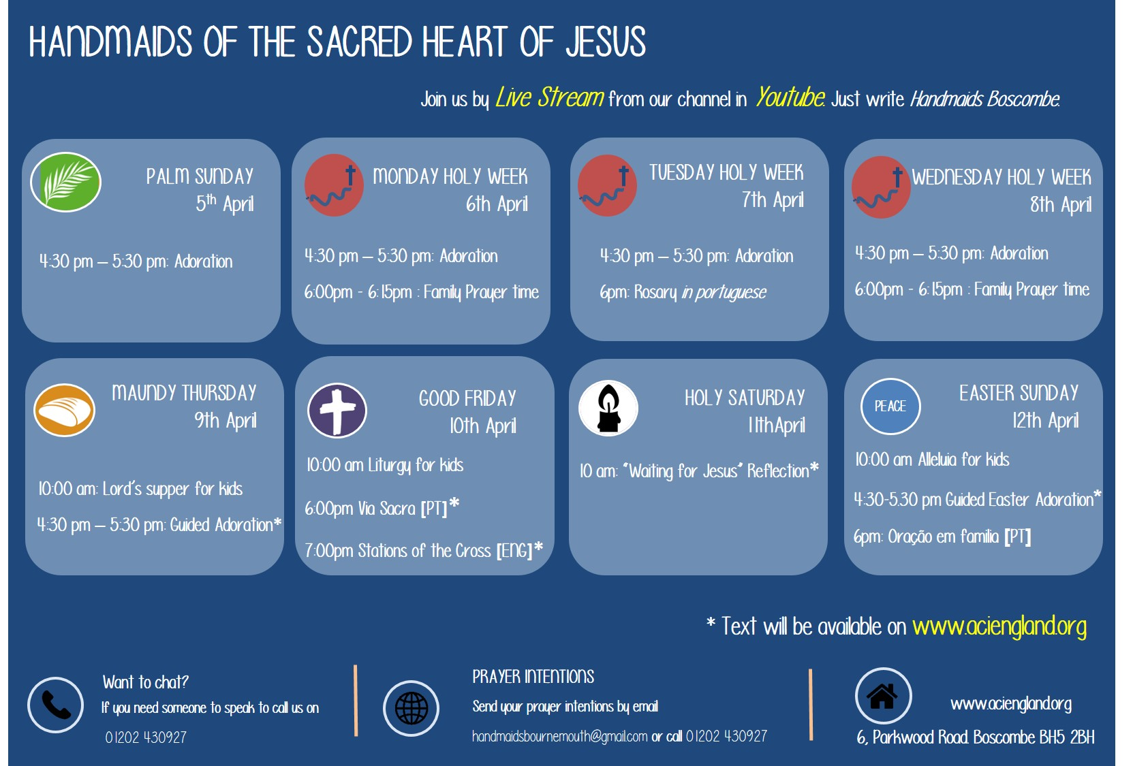

LET’S EXPLORE THE MEANING OF HOLY WEEK:

- PALM SUNDAY OF THE PASSION OF OUR LORD: When the crowds see Jesus, he is on a small donkey. The word spreads that this is he, Jesus of Nazareth, the Messiah. Stories circulate in the crowd about the wonderful things he has done: given sight to the blind, cured the sick, even raised someone from the dead. They want to see him with their own eyes. The mood is filled with excitement. People waving palms grow in number surrounding Jesus. Let’s imagine that we are there, waving our palms, welcoming Jesus into our lives.
But we know that this is the beginning of Jesus’ passion...

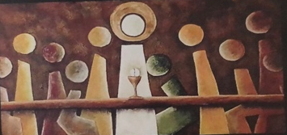
2.HOLY THURSDAY: THE LORDS SUPPER
“I have longed to eat this meal with you”
On Holy Thursday Jesus, totally disrupted the traditional expectations of his time and culture by transforming the Jewish Passover Meal into our Catholic Mass. He changed the ritual handwashing before the meal into the Washing of the Feet, in a gesture that stunned his disciples: one of unconditional service. He then shocked them even more by taking the bread and the wine and saying: “This is my body, This is my blood”. The “wow” moment of history: that happens again and again, every time Mass is celebrated because Jesus said: “Do this in memory of me”! But an ominous darkness is gathering. St John writes: “And it was night.” All black!! Jesus leaves the Last Supper and goes out to the Garden of Gethsemane – where he is betrayed and arrested.
3.GOOD FRIDAY

“GOD SO LOVED THE WORLD THAT HE GAVE HIS ONLY BEGOTTEN SON.”
Good Friday is about PASSION: Jesus’ physical suffering that saves us and sets us free
and the passionate love of God for each and every one of us.
The Gospel of Our Lord’s passion is ultimately the definition of our faith, of what we believe as baptized Catholics. As we read it or listen to it online, let’s hold Jesus seven words from the cross in our minds and our hearts:

- My God , my God why have you forsaken me?
- Father, forgive them, for they do not know what they are doing.
- Today you will be with me in Paradise.
- Father into your hands I commit my spirit.
- Woman: Here is your son. Here is your mother.
- I am thirsty.
- It is finished.
HE MADE IT! HE DID IT! HE GAVE HIS LIFE FOR US. HE SET US FREE!

4. HOLY SATURDAY

LEARNING TO WAIT IN THE DARK
On Good Friday, there is no Eucharist - simply a communion service, with the Body of Christ from the Holy Thursday Eucharist. On Holy Saturday, there is no liturgy at all. The liturgy this evening is the vigil - the preparation for and entry into the celebration of Our Lord's Resurrection. Holy Saturday is the day when nothing happened. Jesus was dead and buried. It is a day to enter into the mystery and wait, a day of empty waiting. Whatever happened to Jesus between Saturday and Sunday, it happened in the dark, with the smell of damp stone and dug earth in the air. There were no witnesses of what happened. Everyone who saw Jesus alive again saw him afterwards.
Tonight, communities from all over the world usually gather in darkness, a darkness that represents all that we have been reflecting upon today. And there, in that darkness, a fire is lit. That flame is shared around the community until its light fills the room. Then, a song of exultation is sung, proclaiming that Christ is the light of this night. That he did not stay
dead but is alive now forever and for always. ALLELUIA.
TIPS FOR PRAYING IN LOCKDOWN 🙏
1.Why not use different spaces in your home to pray during HOLY WEEK, Using different rooms to relive the story of the passion and journey through the mystery of God’s love. Each room could offer something which reflects the mysteries. E.g. The Last Supper in your dining room.,

2.Keep a “COVID-19 Gratitude Journal.” Each day, to write down the things you’re
most grateful for. Every day has at least something in it that is good. However bad things get, God continues to be with us, to love us and will never abandon us. THAT is why we call the Gospel the Good News. Because however tough the situation of the present moment, knowing, loving and serving God and one another, that is the ultimate reason why we’re here.

HELP NEEDED!! URGENT!!

Dear Parishioners,
The Corpus Christi website [websitewww.corpuschristiboscombe.org.uk] can keep you in touch with parish's response to Covid-19 and items on prayer and various contacts.
I hope you'll forgive me if I mention collections - real not virtual.
As our personal and family budgets have not stopped because of the restrictions, so our parish has to keep paying its bills. Without Sunday masses when collections are made; we must keep closer than usual watch on the parish finances.If you can help in anyway - and we realise that this simply may not be possible, we would be so grateful. Could you consider to sign up a Banker's Standing Order? Or you can donate on line through the Everyclick link which will very soon be on our website.
Please be assured that Fr Adrian and the Jesuit community are daily remembering all the parish at the celebration of private Mass. Fr Adrian send is prayers and love to all.
Thank you Aidan Foy Chair of Finance Committee.

